**Q.1. Find the number of GoogleKnowlege_Occupation people who were guests in the show, in a particular time period. Take the time period as 1/11/99 to 6/11/99 i.e., 6 months**

**Driver:**

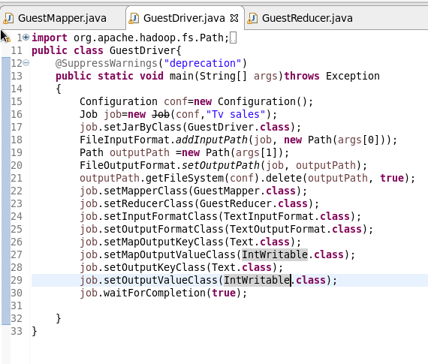

**Mapper:**

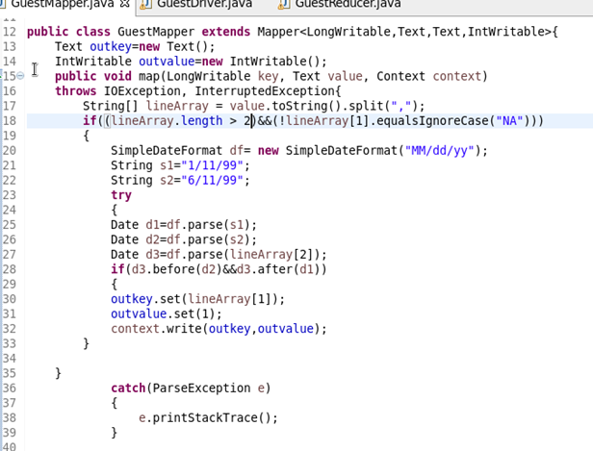

**Reducer:**

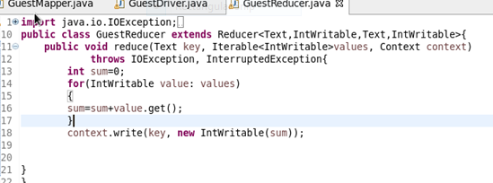

**Output:**

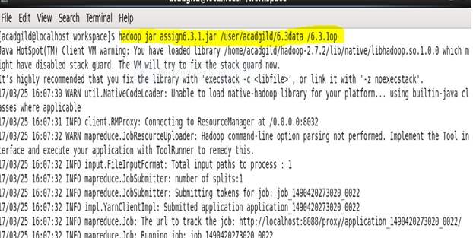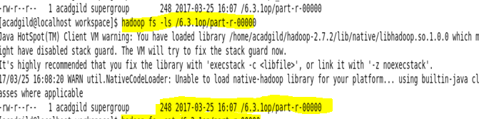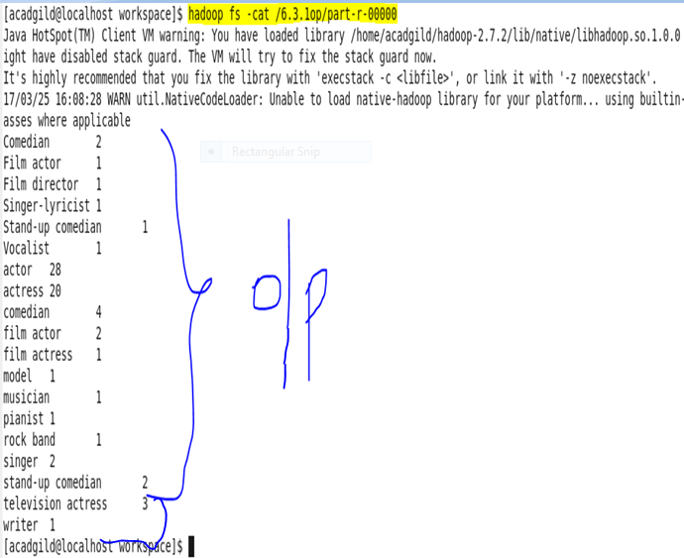

**Q.2. Find the number of GoogleKnowledge occupation types in each group, who have been guests on the show.**

**Driver:**

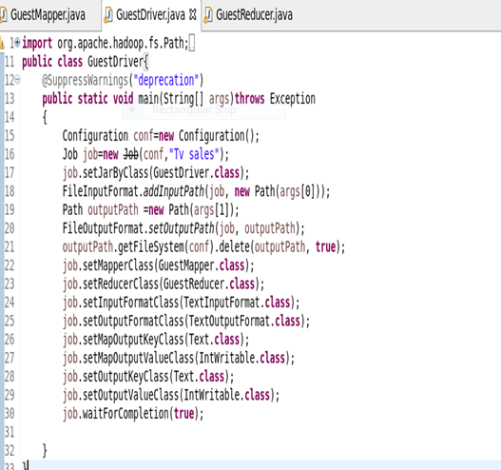

**Mapper:**

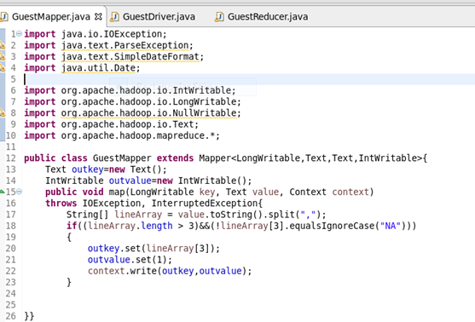

**Reducer:**

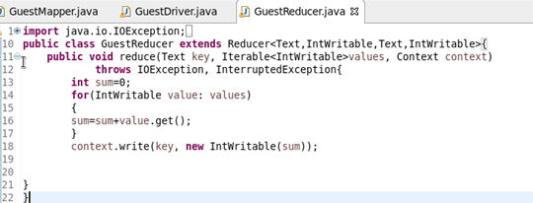

**Output:**

